**Steps to Changing the Jenkins Home Directory**

1. Click on **Manage Jenkins** in the left corner on the Jenkins dashboard.

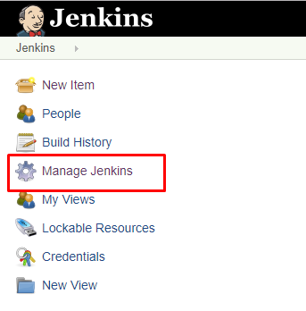

*Manage Jenkins*

2. Select the **System Information** tab.

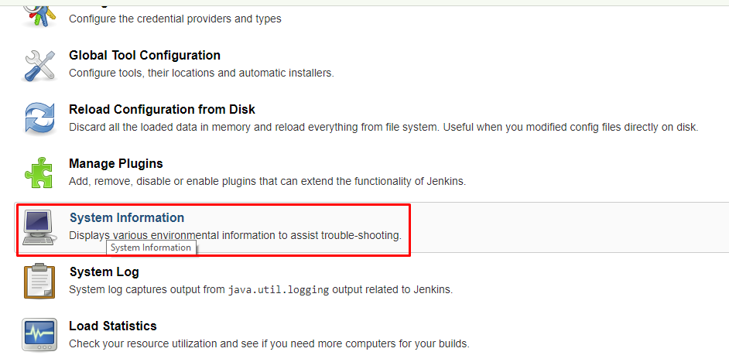

*System information*

3. Scroll down to the **Environment Variables** section and you will see **JENKINS_HOME**

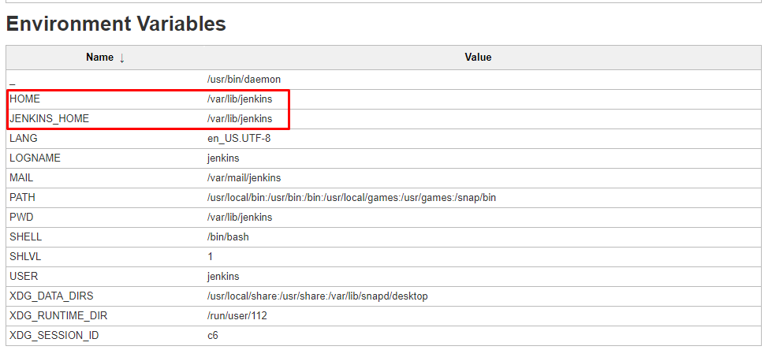

*Environment variables*

4. Change the Jenkins home login to [Jenkins server instance](https://dzone.com/articles/how-to-build-you-own-personal-jenkins-ci-server) using **Putty.**

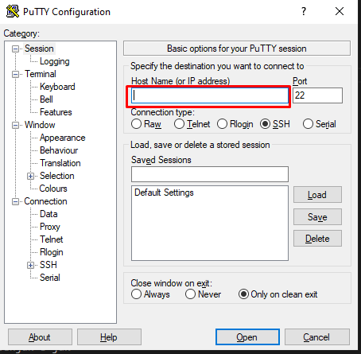

*Using Putty*

5. Navigate to the root user using the following command.

sudo -i

6. Before changing anything on the Jenkins master we have to stop the Jenkins server.

sudo systemctl stop jenkins

7. you have to mount the storage

sudo mount -t cifs --verbose -o vers=3.1.1,cache=none,user={username},uid=jenkins,gid=jenkins "[{sharedpath}](https://resolutionlifeus.com/dfs/sharedservices/userapps/devops)" /mnt/jenkins/

enter the password for the user

8. Create a new directory where ever you want to move the Jenkins home to. In this article, I’m creating a new directory in the /homepath.

mkdir /mnt/**jenkins**

9. We need to change the ownership of a created directory by using the chown command to change the user and group ownership of the created directory.

sudo chown -R jenkins:jenkins **/mnt/jenkins**

10. Copy the content from old Jenkins home directory, /var/lib/jenkins , to the new Jenkins home directory, **/mnt/jenkins,** using the following command.

sudo cp -prv /var/lib/Jenkins/* **/mnt/Jenkins/**

11. Next, change the Jenkins user home by using the following command.

sudo usermod -d **/mnt/jenkins/ j**enkins

12. Update the new Jenkins home directory path in sudo vi /etc/sysconfig/jenkins

sudo vi /etc/default/Jenkins 🡪 ubuntu linux servers

sudo vi /etc/sysconfig/Jenkins 🡪 RedHat linux servers

13. Scroll down to the Jenkins home location and update the new home directory path.

14. Start the Jenkins service by using the following command.

sudo service jenkins start

15. Then we need to update the admin password that can be found in a new Jenkins home directory.

cat **/mnt/jenkins/**secrets/initialAdminPassword

16. Copy and paste the Admin Password in the Administrator Password field. Click the continue button.

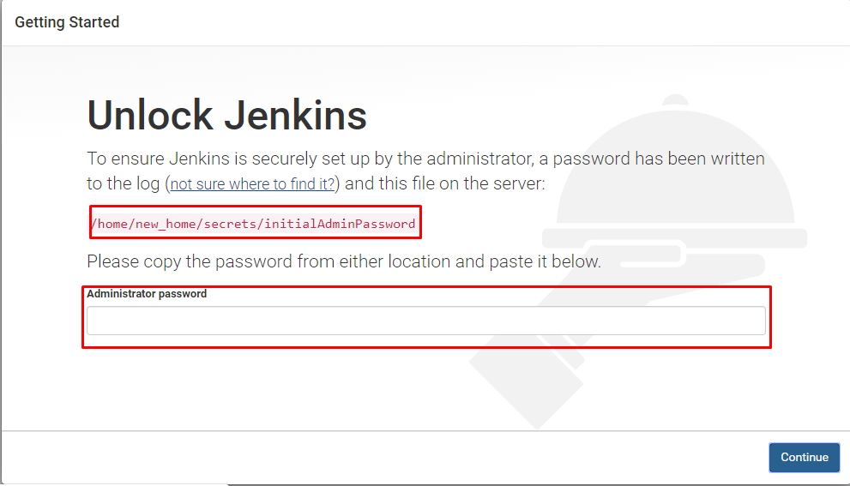

*Unlock Jenkins*

16. Next, you will be prompted to set up the first admin user. Fill out all required information and click the **Save and Continue**button.

17. Set the URL for your Jenkins instance. The URL will be generated automatically. Confirm the URL by clicking the **Save and Finish** button.

18. Once all configuration is done, you can see the "Jenkins is ready" screen. Click **Start using Jenkins** and you will be redirected to the Jenkins dashboard.

19. Click on **Manage Jenkins** in the left corner on the Jenkins dashboard, then select **System Information**.

20. Scroll down to the **Environment Variables** section, you will see the new JENKINS_HOME.

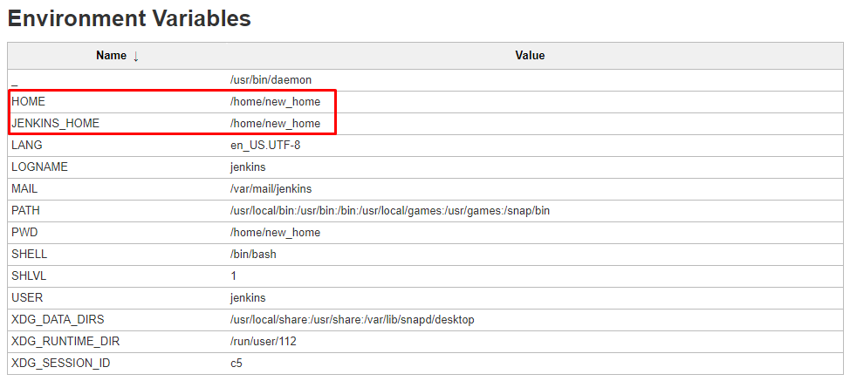

*New JENKINS_HOME*

**Create a Freestyle Project**

Once the Jenkins home directory is changed, we can test previously created or [new jobs](https://dzone.com/articles/part-01-install-jenkins-on-ubuntu). For the sake of this article, I created a new freestyle project.

1. Select **New Item**in the top left-hand corner on the dashboard.

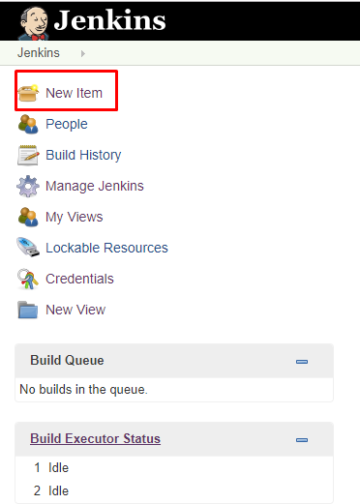

*New item*

2. Enter the name of your project in the **Enter an item name** field, and select **Freestyle Project**, and click the **OK** button.

3. Enter a description (optional).

4. Go to the **Build** section and click on the **Add build step**.

5. Select **Execute Shell** as a build step.

6. Copy and paste the following command into a **command** field.

echo $HOME

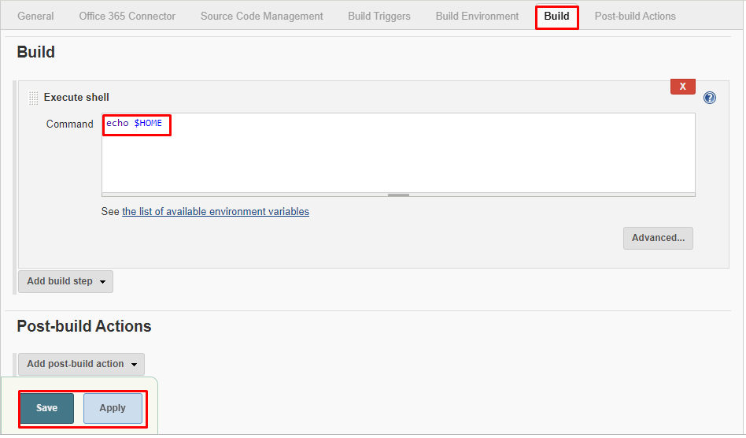

*Execute shell*

7. Click on **Save**, it will redirect to the job's view page.

8. On the left pane, click the **Build Now** button to execute your job.

9. We can verify the history of executed build under the **Build History** by clicking the build number, which is #1 in this case.

10. Click on build number and select **Console Output**. Here, you can see the Jenkins user home and Jenkins home directory.  
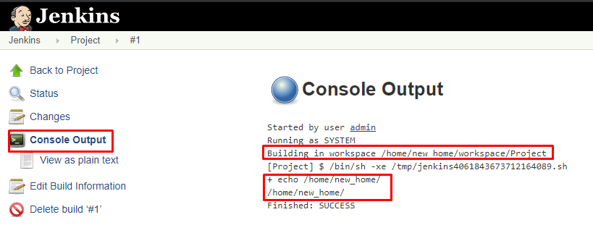

Reference:

<https://www.aws.ps/how-to-implement-jenkins-automation-on-aws/>

<https://dzone.com/articles/jenkins-02-changing-home-directory>